QUESTION NO 1 :

CODE:

a=int(input("first side of right triangle"))

b=int(input("second side of right triangle"))

from math import sqrt

def printme(a=1,b=1):

f=a\*\*2+b\*\*2

hyp=sqrt(f)

print(hyp,"hyp")

return f,hyp

printme()

OUTPUT:

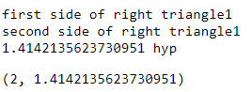

QUESTION NO 2:

CODE:

x=int(input("enter a number"))

y=int(input("enter a number"))

z=int(input("enter a number"))

if x%2>0:

print(x,"is the gretest odd number")

elif y%2>0:

print(y,"is the gretest odd number")

else:

print(z,"is the gretest odd number")

x=int(input("enter a number"))

y=int(input("enter a number"))

z=int(input("enter a number"))

if x%2>0:

print(x,"is the gretest odd number")

elif y%2>0:

print(y,"is the gretest odd number")

else:

print("None of them is odd number")

x=int(input("enter a number"))

y=int(input("enter a number"))

z=int(input("enter a number"))

if x%2==0:

print(x,"is the gretest odd number among them")

elif y%2>0:

print(y,"is the gretest odd number among them")

else:

print(z,"is gretest odd number among them")

x=int(input("enter a number"))

y=int(input("enter a number"))

z=int(input("enter a number"))

if x%2>0:

print(x,"is the gretest odd numbera among them")

elif y%2>0:

print(y,"is the gretest odd number among them")

else:

print(z,"is gretest odd number among them")

OUTPUT:

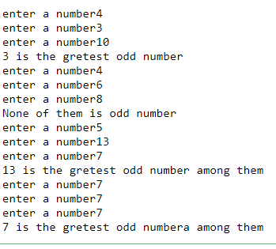

QUESTION NO 3:

CODE:

year=int(input("enter a year"))

def isleap(year):

if year%4==0 and year%400==0 and year%100!=0:

print(year,"leap year")

else:

print(year,"year is not a leap year")

isleap(year)

year=int(input("enter a year"))

def isleap(year):

if year%4==0 and year%400==0 and year%100!=0:

print(year,"leap year")

else:

print(year,"is not a leap year")

isleap(year)

year=int(input("enter a year"))

def isleap(year):

if year%4==0 or year%400==0 or year%100!=0:

print(year,"is a leap year")

else:

print(year,"is nota leap year")

isleap(year)

OUTPUT:

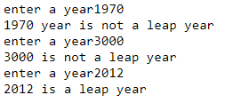

QUESTION NO 4:

CODE

Ni ho raha sir ye